**Http Header Response(status code & desc) write into DB**

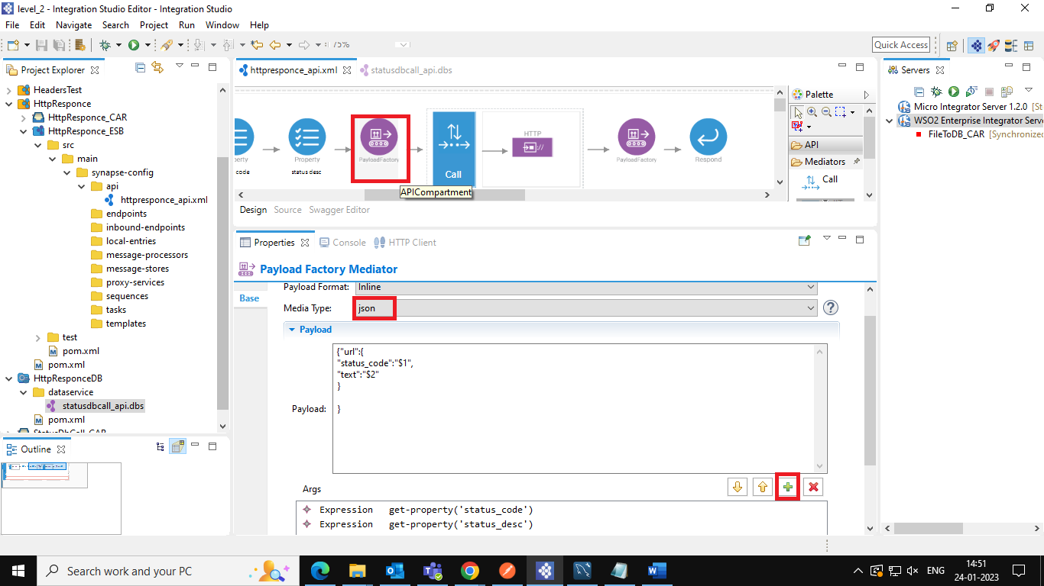

**Insert Dataservice creation in Integration Studio**

